Shape memory alloy bi-morphs and their applications
Palani I.A.^{1*}, Vipul Singh ², Santosh Hosmani³
¹Mechanica^{l} Engineering Discipline, Indian Institute of Technology Indore, Indore, India
²Electrical Engineering Discipline, Indian Institute of Technology Indore, Indore, India
³Metallurgy Engineering and Material science, Indian Institute of Technology Indore, Indore, India

*Corresponding author: palaniia@iiti.ac.in

Abstract: This document gives formatting instructions for authors preparing papers for publication in the journal. Authors are encouraged to prepare manuscripts directly using this template. This template demonstrates format requirements for the Journal.
Keywords: Format, Microsoft Word Template, Style, Insert, Template
1. Introduction
To use this template, you will need to (1) apply the embedded styles to each paragraph-level item in your manuscript or (2) use the specifications shown in Table 1 to format your manuscript, with this template as a visual guide. Information about paper submission is available from the Journal website.
1.1. Text Font
The entire document should be in times New Roman font size 10. Paper title must be centered, bold, regular font size 20 and all with upper case. Author names must be centered, bold, regular font size 10 . Author affiliation must be regular font size 9. Email address must be centered, italic, font size 9. Recommended font sizes are shown in Table 1. No more than 3 levels of headings should be used. Level 1 heading must be left-justified, bold, regular font size 14 and numbered using Arabic numerals. Level 2 headings must be left-justified, bold, regular font size 12 and numbered as sub-heading (i.e 1.1). Level 3 heading must be left-justified, bold, italic font size 10 and numbered as sub-sub heading (i.e 1.1.1) and the first letter of each word capitalized.
2. Ease of Use
An easy way to comply with the journal paper formatting requirements is to use this document as a template and simply type your text into it.
The template is used to format your paper and style the text. All margins, column widths, line spaces, and text fonts are prescribed; please do not alter them. Your paper is one part of the entire proceedings, not an independent document. Please do not revise any of the current designations.

2.1. Page Layout
Your paper must use a page size corresponding to A4 which is 210mm wide and 297mm long. The margins are set as follows: top= 15 mm, bottom= 15 mm, right=17.5 mm, left = 20 mm. Your paper must be in two column format with a space of 1.93 characters between columns.
2.1.1. Front Matter
The title should be formatted in an hourglass style; the first line longer than the second, the second line shorter than the third. Use numerical superscript callouts as shown in this template to link authors with their affiliations. Corresponding author should be denoted with an asterisk as shown. Email address is compulsory for the corresponding author.
2.1.3. Equations
Display equations should be broken and aligned for two-column display unless spanning across two columns is essential. Equations should be centered with equation numbers set flush right. If using MathType, use the Format Equations feature to format all equations as Times + Symbol 10.
(1)
2.1.4. Tables
Styles for table title, table head, and table text are provided. Tables should be set in one column wherever possible and be placed near their first mention in the body. Tables and figures do not need to be placed on separate pages at the back of the manuscript.

Table 1. Font Sizes for Papers
Font Size | Appearance (in Time New Roman)
Font Size | Regular | Bold | Italic
8 | cell in a table  reference item | table caption,  figure caption,
9 | author affiliation |  | author email address,
10 | paragraph  abstract body | author name  level-3 heading, | Received Line
12 |  | level-2 heading,
14 |  | level-1 heading,
20 |  | title

2.1.5. Figures
As with tables and equations, figures should be set in one column if possible unless two-column display is essential. The resolution of graphics and image should be adequate to reveal the important detail in the figure.
2.1.6. Figure Captions
Figure captions should be below the figures. Figures must be numbered using Arabic numerals. Figure captions must be in 8 pt Regular font. Captions of a single line (e.g. Fig. 2) must be centered whereas multi-line captions must be justified (e.g. Fig. 1). Captions with figure numbers must be placed after their associated figures, as shown in Fig. 1.
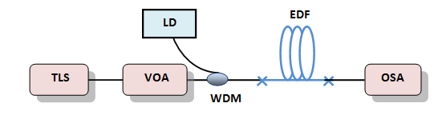
Fig. 1. (Color online) Forward single pass experimental set-up for evaluating EDFA performance
Fig. 2. Diagram example
2.1.7. Table Captions
Table heads should appear above the tables. Tables must be numbered using Arabic numerals. Table captions must be centered and in 8 pt Regular font.. Every word in a table caption must be capitalized. Captions with table

numbers must be placed before their associated tables, as shown in Table 1.
2.1.7. Analysis at joint for Torque and Angular Displacement
The most important characterising factor for upper limb prosthesis is the gripping capacity and holding capacity. Both of which depends on the maximum joint torques in all positions of prosthetic hand. Hence we have calculated joint torques both theoretically and practically. Analysis for joint torque was done on a scale model of a finger depicting a human finger with four degrees of freedom (DOF). The finger was actuated with SMA NiTi spring at each joint independently to reduce the couplings.

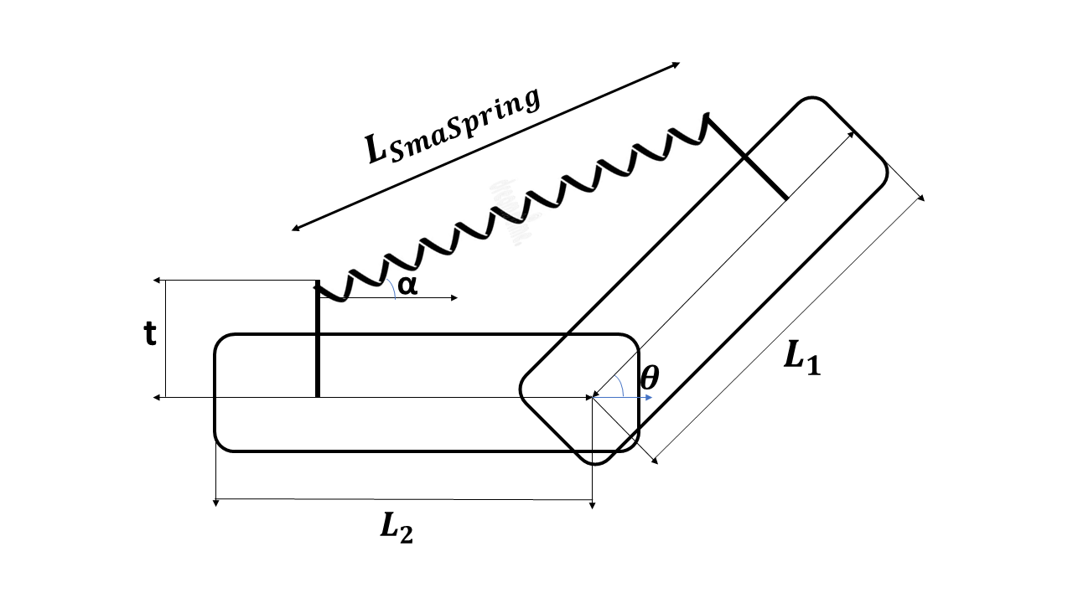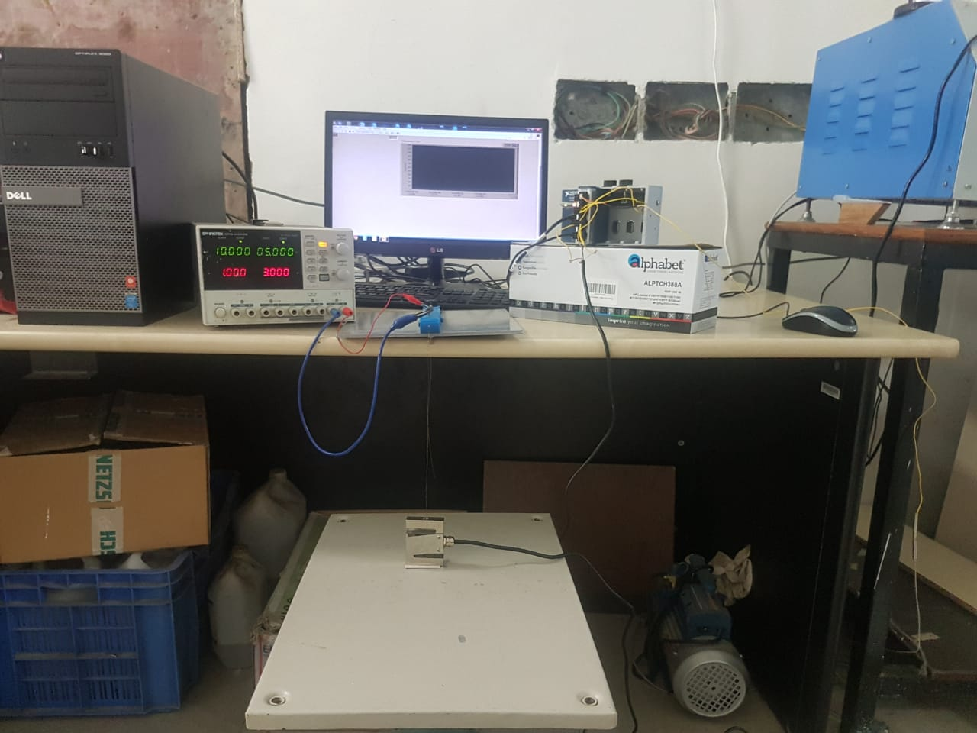
Fig. 3. Diagram example
Shown in figure 3 is a schematic representing a joint of finger. With simple geometric calculations we can relate the angle between the joint to the torque. The same has been done and the relation is in the form of equation 3. From the equation the theoretical values were calculated for joint torques, with keeping the Force as 8 N. For the experiment, the values for L1, L2 and t were 2 cm, 3.5 cm and 2 cm respectively.
The length from center to the point of action of torque is
R1=L₂*Sin (θ)+t*Cos(θ) (1)
R2 =L₂*cos(θ)t*sin(θ) (2)
So, the torque at joint from F(force from SMA NiTi Spring) is
Net Torque = F_{effective} Positive* R₁F_{effective}(Negative)*R₂(3)

For Experimental values we used the setup shown in figure 3 (b). The Load cell was attached to one end of Finger with 0.5mm Brass wire. The load cell was held and then for different angles the SMA NiTi spring was actuated with 5 Volts and maximum allowable 3 Ampere.
Further we experimentally determined the angular velocity of joint when the SMA NiTi Spring actuated with 5 Volt and 3 Ampere. The Angular velocity was plotted vs time and shown in figure 3.
3. References Formats
The heading of the References section must not be numbered. All reference items must be in 8 pt font. Number the reference items consecutively in square brackets (e.g. [1]). When referring to a reference item, please simply use the reference number, as in [2]. Do not use “Ref. [3]” or “Reference [3]” except at the beginning of a sentence, e.g. “Reference [3] shows …”. Multiple references are each numbered with separate brackets (e.g. [1], [2]–[3]).
A complete reference should contain the name(s) of the author(s) and/or editor(s), the title of the article, the name of the book or conference proceedings where appropriate, and bibliographic information about the article such as the name of the publisher, the city of publication, and the page numbers. The basic concept is that the reference should be sufficiently complete so that the reader could readily find the reference and can judge the authority and objectivity of the reference.
Books
Standard format
Authors, Title(in italics), Publisher, City of Publication, Year of Publication, page numbers(if appropriate).
Example:
1. Fogg, B.J, Persuasive technology: using computers to change what we think and do, Morgan Kaufmann Publishers, Boston, 2003, 30-35.
Journal articles
Standard format
Authors, "Title of the article," Journal name (in italics), Volume (Issue), Pages, Month Year.
Example:
Hirsh, H., Coen, M. H., Mozer, M.C., Hasha, R. and Flanagan, J.L, "Room service, AI-style," IEEE intelligent systems, 14 (2). 8-19. Jul.2002.
Conference Proceedings
Standard format
Authors, "Title of the article," in Title of conference (in italics), Publisher, Pages.
Example
Leclercq, P. and Heylighen, "A. 5,8 Analogies per hour: A designer's view on analogical reasoning," in 7th International

Conference on Artificial Intelligence in Design, Kluwer Academic Publishers, 285-303.
E-Books
Standard format
Authors, Title of E-book(in italics),Publisher, Date of original publication. [Format] Available: Source.
Example
T. Eckes, The Developmental Social Psychology of Gender, Lawrence Erlbaum, 2000. [E-book] Available: netLibrary e-book.
E-journal
Standard format
Authors, "Title of Article," Title of Journal(in italics), Volume (Issue), pages, month year. [Format]. Available: Database Name (if appropriate), article number (if given),
internet address. [Accessed date of access].
Example
A. Altun, "Understanding hypertext in the context of reading on the web: Language learners' experience," Current Issues in Education, 6(12), July 2003. [Online].
Available: http://cie.ed.asu.edu/volume6/number12/.[Accessed Dec. 2, 2004].
Acknowledgement
The heading of the Acknowledgment section and the References section must not be numbered.
References
- “Census of India 2011” - http://censusindia.gov.in
- Dechev, N., Cleghorn, W.L., Naumann, S.: Thumb design of an experimental prosthetic hand. In: International Symposium On Robotics and Automation, pp. 7–12. Monterrey (2000)
- Touch Bionics, Inc.: i-Limb Ultra Revolution data sheet
- “The Jaipur Foot” - http://jaipurfoot.org/index.html
- Waram, T., 1993, Actuator Design Using Shape Memory Alloys, 2nd Edition
4-6 pages

